|  |  |  |
| --- | --- | --- |
| E1 | E2 | S |
| 0 | 0 | 0 |
| 1 | 0 | 0 |
| 0 | 1 | 0 |
| 1 | 1 | 1 |

AND (et)

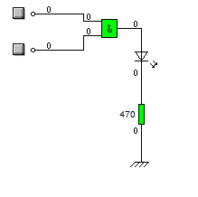

NAND (et non)

|  |  |  |
| --- | --- | --- |
| E1 | E2 | S |
| 0 | 0 | 1 |
| 1 | 0 | 1 |
| 0 | 1 | 1 |
| 1 | 1 | 0 |

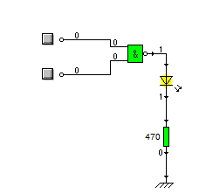

OR (ou)

|  |  |  |
| --- | --- | --- |
| E1 | E2 | S |
| 0 | 0 | 0 |
| 1 | 0 | 1 |
| 0 | 1 | 1 |
| 1 | 1 | 1 |

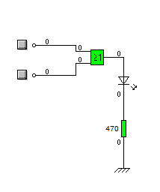

XOR (ou exclusif)

|  |  |  |
| --- | --- | --- |
| E1 | E2 | S |
| 0 | 0 | 0 |
| 1 | 0 | 1 |
| 0 | 1 | 1 |
| 1 | 1 | 0 |

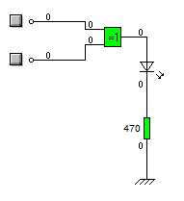

NOT (non)

|  |  |
| --- | --- |
| E | S |
| 0 | 1 |
| 1 | 0 |

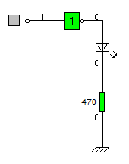

II.

A.

1010

+ 1111

11001

B.

|  |  |  |  |
| --- | --- | --- | --- |
| Table de vérité du montage | | | |
| E1 | E2 | S1 | S0 |
| 0 | 0 | 0 | 0 |
| 1 | 0 | 0 | 1 |
| 0 | 1 | 0 | 1 |
| 1 | 1 | 1 | 0 |

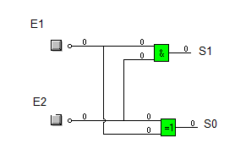

C.

|  |  |  |  |  |
| --- | --- | --- | --- | --- |
| Table de vérité de l’additionneur | | | | |
| R0 | E1 | E2 | S1 | S0 |
| 0 | 0 | 0 | 0 | 0 |
| 0 | 0 | 1 | 0 | 1 |
| 0 | 1 | 0 | 0 | 1 |
| 0 | 1 | 1 | 0 | 1 |
| 1 | 0 | 0 | 0 | 1 |
| 1 | 0 | 1 | 1 | 0 |
| 1 | 1 | 0 | 1 | 0 |
| 1 | 1 | 1 | 1 | 1 |

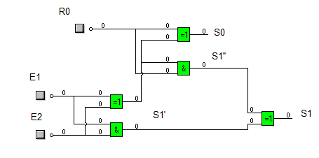

d.

